Transport in the world

Did you know that…
- The number of cars on the world’s roads surpassed 1 billion in 2010.

- The number of cars worldwide would reach 2,5 billion by the 2050.

  - This would require the world to produce at least 120 million barrels of oil per day, up from about 87 million today.
  - Given the slow depletion of conventional oil sources and the gradual increase of the prices, it’s not clear the world could develop such a large capacity to produce oil.

- Transportation currently accounts for 23 % of the world’s greenhouse gas emissions.

Use of car in the world Vehicles per 1.000 people
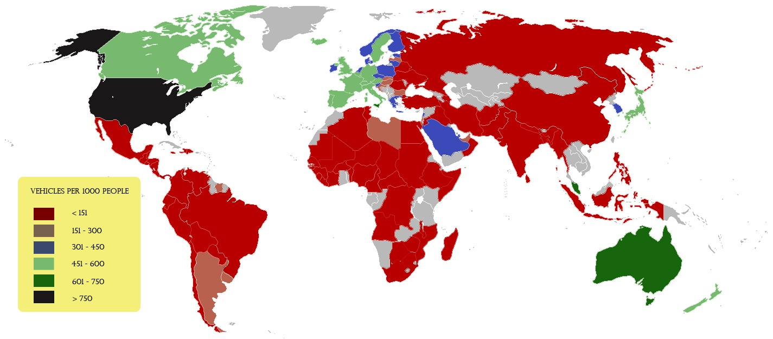

Use of car in the world Passenger cars

Transport in the UK

What means for the environment…
Did you know that…
- There are 28.5 million cars in the UK and the average car owner produces over two tonnes of CO₂ each year.

- Our roads are already the most heavily used in Europe, yet this will bring an increase in traffic volume and in turn, more delays.

- CO₂ emissions from cars make up 13% of the UK total.

- Continue as we are, UK transport CO₂ emissions are expected to rise by 35% between 1990 and 2030.

What means for our health…
Did you know that…
- Regard to some studies, the lack of physical activity could cause over 36,000 premature deaths in England each year.

- It’s recommended that adults take part in 2.5 hours of moderate activity per week. But in the UK: only 40% of men and 28% of women meet these minimum recommendations.

- Air pollution is a big killer, causing 29.000 premature deaths each year in the UK and 4.300 in London.

Cycling, a good option

Did you know that…
- Research shows that regular adult cyclists have fitness levels of someone 10 years younger.

- Moderate pedal-pushing burns up to 500 calories per hour, which is more than walking or swimming.

- Those who travel by car can experience five times higher pollution levels than those who cycle, and three and a half times more than those walking.

- A 20-minute bike ride to work could use the same amount of calories as a cappuccino, a bar of chocolate or a 175ml glass of wine.

- Cycling is the least polluting way of travelling after walking.

- 2 kg of carbon are saved for every short journey that is made using a bike instead of a car.

Arrive fashionably early
- In medium-sized cities cycling can often be twice as quick as driving and your journey time won’t vary with traffic, so you can normally arrive on time.

- Free parking – it costs you nothing, as long as you don’t park where you’re not meant to.
Spend your money on you
- The average cost of maintaining a car each year is £273 compared to just £75 for a bike.

- An average household in the UK spends one in every six pounds on travel – think how much you’ll save if you travel by bike.

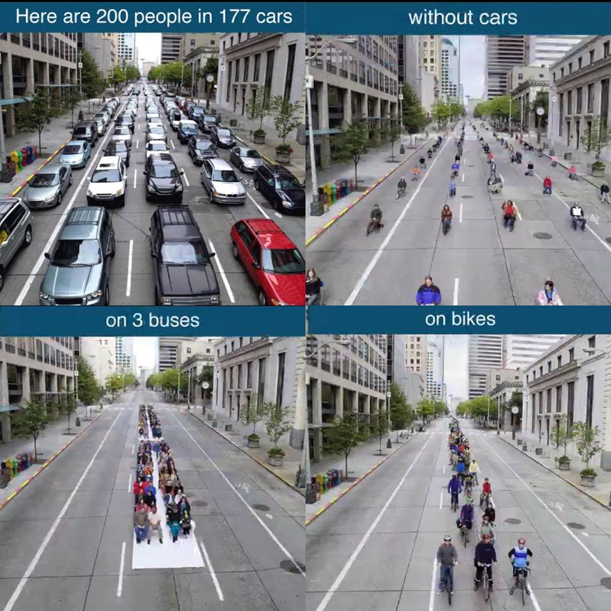
Ten bikes can be parked in the space of one car
And for long journeys…

Did you know that…
- CO₂ emissions per passenger for train and coach are, on average, six to eight times lower than car travel. And, on average, trains create one third of the CO₂ emissions of a plane.

What can I do?
- Plan your journey with enough time, you’ll get important discounts on train and bus.

- Use can-sharing and car clubs, they are a cheap option and you’ll meet people.

Car-sharing:
What is it?
Car-sharing (also called lift-sharing, ride-sharing and car-pooling) is when two or more people share a car and travel together. You can benefit from the convenience of the car, whilst reducing the costs and the number of one-person cars on the road, which can help reduce pollution and congestion.
How does it work?
Whether you’re seeking a lift or offering one, register on Liftshare.com to advertise a lift you want to share:
- all members' details are stored securely in the database and only the members' travel information can be viewed by other members;
- follow Liftshare’s safety tips before you travel, ensuring you don’t give out personal details and you meet somewhere public the first time you travel together;
- it’s down to the car-sharers to decide how to pay for the journey, but it’s a good idea to share the cost of petrol. Drivers shouldn’t make a profit from lift-sharing or it could invalidate their insurance or tax;
- consider setting up a car-sharing group for your company, community or organisation.

Car clubs:
What is it?
Car clubs work by giving members access to a car on a short-term rental basis, and charging by the hour or the day. Just book a car online or by phone and then unlock it from a designated bay in your local neighbourhood.
Why join a car club?
Car clubs can provide a great alternative to car ownership as you get all the convenience of a car without any of the hassle.
No road tax or fuel to pay, no MOT or car servicing to worry about – all you pay for is membership and car hire. If you’re a low-mileage driver then you could benefit financially from joining a car club - members who drive less than 6-8,000 miles per year could save up to £3,500 a year.
You’ll be dramatically reducing your impact on the environment, too. Car club cars are more environmentally friendly, emitting over 20% less CO2 per kilometre than the average car, and they are used more efficiently. One car club car replaces over 20 private cars, helping to reduce traffic jams and free up parking spaces

Wednesday 6 March 2013. The Guardian

Joanna Moorhead. If you live in a city, you don't need a car
Cars cost – and how. According to the RAC, we spend between 12% and 26% of our disposable income on buying and running a car – and, unsurprisingly, the poorest households spend the biggest proportion of their funds on them.
The RAC sees this as the strongest argument yet for a reduction in fuel duty in the upcoming budget. "These figures should shock the chancellor," says ProfStephen Glaister, director of the RAC Foundation. "It lays bare the truth about the extent of transport poverty in the UK."
But I think there's another truth to bring into the mix here – a truth that's hit me in the face over the last few months, but one most people seem unwilling or unable to acknowledge. It's this: many of us who are running cars don't need them. We think we need a car, but we don't. And when we're brave enough to give it a try, we realise we can manage perfectly well without one – while saving a fortune in the bargain.
I wasn't brave, I admit that. I was nervous – desperately nervous – about becoming car-free. But eight months ago our elderly people carrier (I've got four kids, so we needed a large vehicle to transport everyone around) was hit by a passing vehicle while it was parked outside our house, and the damage was so bad it had to be written off. No problem, I thought: we'll buy another. But the insurance payout didn't even begin to cover the costs of buying a new car – I worked out that, with the loan we'd need plus petrol, insurance, parking permits and tax, we could easily be looking at around £600 a month.
And that's when I had my eureka moment. Why not just give up having a car at all? The more I thought about it, the more sensible it seemed. I live in London. We have a railway station behind our house, a tube station 10 minutes' walk away, and a bus stop at the end of the street. Added to which, a new car club had just opened in our area, and one of its shiny little red Peugeots was parked nearby. If any family in Britain could live without a car, I reasoned, then surely we were that family?
But my new car-free evangelism, sadly, wasn't shared by my family. My teenage daughters were horrified. How would they get to and from university? (A coach, I suggested.) How would they get home from parties across town late at night? (Isn't that what taxis are for? And yes, I do realise they're more expensive than mum and dad driving, actually.) What would their friends think about our family being "too poor to afford a car"? (I wasn't that bothered what they thought, and I suggested they could take the same approach.)
My friends, too, were astonished at our plan – even friends who live in London. Wasn't a car essential, when you had children? What would happen if someone got seriously ill overnight and needed to go to hospital (erm … an ambulance?). How would the children get to and from their many events? (Well, there are always all those buses and trains.) People smiled indulgently, as though this was another of my mad ideas, before saying they were sure I'd soon realise that a car wasn't a luxury, it was a necessity.
Eight months on, I wonder whether we'll ever own a car again. The idea that you "have" to own a car, especially if you live in a city, is all in the mind. I live – and many other city-dwellers do too – in a community that has never been better served by public transport, and yet car ownership has never been higher. We wring our hands, as the RAC is doing today, over rising car costs, but we'd be better off asking something much more basic. Do I really need a car? The answer, for me, turned out to be no, and I'm a lot richer because I dared to ask the question.

Advice for sustainable mobility:
General advice
The best transportation is the one you don´t need
Is it always necessary to move so much and so far? Make an overview of the places to which you are traveling more often and think about whether and how you could reduce the number of trips you make.
Chooses the near-by: the neighborhood stores
Discover nearby shops and what possibilities they offer to prevent or reduce long journeys to distant shopping centres. Compare the prices, but introduce in the calculation the expenditure of time and fuel. Maybe you will be surprised...
The car is not always the best option
The best option for short trips (around 2 km) is certainly walking not only in terms of health and ecology, but for saving time as well; for medium trips (5 - 6 km), the bicycle may be the most advantageous means; for long journeys, public transport is often the best option. Before taking the car, make sure you really do not have a better alternative.
Public transport, the unknown friend
Are you a car addict? Dare to try public transport! Discover the benefits of reading the newspaper, get rid of jams, avoid looking for parking spaces, talk with lost tourists...
Make the sport of walking your daily habit
Problems of overweight? Does the doctor recommend exercising? You do not have time or interest to go to the gym? The simplest and cheapest solution is to incorporate sport into your daily life, walking to one of your daily destinations. Walking is one of the most complete and healthiest activities, suitable for all ages, and the most efficient alternative from the energy point of view.
Cycling is also a means of transport
Bike has been, until recently, an exotic guest in the streets of many cities and, in any case, it was used for leisure or sport. But something is changing and many cities are beginning to promote the use of the bike as a daily means of transport by creating networks of bike paths, loan systems, installation of bicycle parking spaces, means to transport bicycle in trains and buses, etc. If you have a chance, try it and enjoy the freedom and satisfaction it provides.
Walk to school
How far is your children’s school? If you can reach it with a short walk of 15 to 20 minutes, it makes no sense to drive there. Meet with other families and use the trip to chat, know your neighborhood, stretch your legs... and if you can go by bicycle, it is a good experience! You can even organise a cycling group with other families to go together and feel safer...
Advice for saving… when using a car
Learn to drive efficiently
Even if you have a driver's license for more than 20 years, maybe you do not know some basic tricks of "efficient driving", which is lower the fuel consumption and allows you to use the vehicle better. Here are the main advices:
- Use first gear only to start the car and switch to 2nd 2 seconds after.
- Do not exceed 2.500 rpm in gasoline vehicles and 2.000 in diesel.
- Use the higher gears as much as possible and keep the speed as uniform as possible, avoiding unnecessary gear changes.
- Slow down by lifting the foot off the pedal, letting the vehicle roll with the gear engaged; brake smoothly and as late as possible.
Speed is dangerous and consumes a lot
Fuel consumption soars above 62 mi/h, so here's another good reason for driving at moderate speed, apart from contributing to the safety of the streets and roads.
Turn the car off when you stop
There is nothing more absurd than to burn fuel while the car standing still; if the stop is longer than a minute, turn off the engine not to burn money and pollute the air without any benefit.
Keeping the vehicle in good condition is another type of savings
Check the engine frequently, control the levels and filters and, above all, the tyre pressure: it is a basic safety standard, but it also has a positive environmental consequence because it influences the car´s fuel consumption.
Go easy on the air conditioning
The use of air conditioning represents around a 25 % increase in fuel consumption, so try not to abuse it: an inner temperature of 25-26 °C is perfectly adequate and cheaper!
Avoid bumps on the outside of the vehicle
Any external accessory increases fuel consumption, particularly the roof rack loaded with luggage on the roof of the car. Whenever possible, load inside!
Carpooling for work
Maybe you are one of those who bump into the same person when arriving in the office; and find him/her once more again eight hours later, just when you both are taking your cars to go home. Yes, the same colleague who lives three streets away from your flat. Have you ever considered the possibility of suggesting car sharing to make the daily commute? How much would you save in a year? And maybe you will make a new friend…

