Waste production…

Did you know that…
- …the 20 % of the countries in the world consume the 20 % of resources and produce the 80 % of the waste.

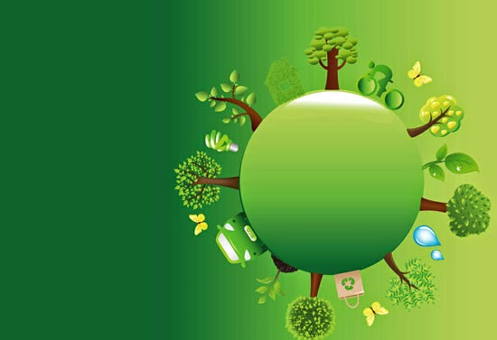

Waste production in the world
Nederlands: 530 Kg/pers/year

UK: 480 Kg/pers/year

US: 460 Kg/pers/year

Switzerland: 450 Kg/pers/year

Australia: 400 Kg/pers/year

Austria: 380 Kg/pers/year

France: 360 Kg/pers/year

Germany: 340 Kg/pers/year

Canada: 330 Kg/pers/year

Waste production in the UK
- The UK produces about 330 million tonnes of waste a year, 480 kg/pers/day.
- Every 8 months the UK produces enough waste to fill Lake Windermere (the largest lake in England).
- On average every person in the UK throws away their own body weight in rubbish every 7 weeks.
Plastic
- 275.000 tonnes of plastic are used each year in the UK, that’s about 15 million bottles and 13 billion plastic carrier bags per day.
- Most families throw away about 40 kg of plastic per year.
Paper
- We use 12,5 million tonnes of paper and cardboard every year in the UK.
- The average person in the UK gets through 38 kg of newspapers per year. It takes 24 trees to make 1 ton of newspaper.
- To grow enough trees to provide the amount of paper that Britain uses each year, you would need a forest the size of Wales.
Aluminum
- 24 million tonnes of aluminum is produced annually, 51.000 tonnes of which ends up as packaging in the UK.
- The UK uses about 12 billion cans each year – that’s enough to stretch to the moon and back!
- £36.000.000 worth of aluminum is thrown away each year.
Glass
- Each UK family uses an average of 500 glass bottles and jars annually.

What happen with food?
- The average UK family is wasting nearly £60 a month by throwing away almost an entire meal a day.
- Almost 50% of the total amount of food thrown away in the UK comes from our homes. We throw away 7 million tonnes of food and drink from our homes every year in the UK. We throw away more food from our homes than packaging in the UK every year.
- Britons are chucking out the equivalent of 24 meals a month. One-fifth of what households buy ends up as waste, and around 60% of that could have been eaten.
- The waste of good food and drink is associated with 4% of the UK's total water footprint.
- The carbon associated with avoidable household food waste is equivalent to taking one in four cars off UK roads.
- 19.000 square kilometres or an area about 91% the size of Wales is required to produce the food is through away in UK.
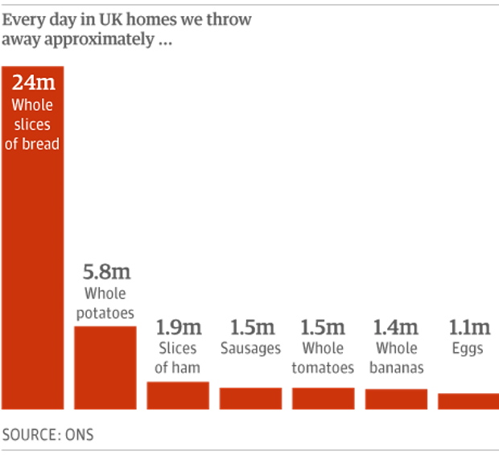
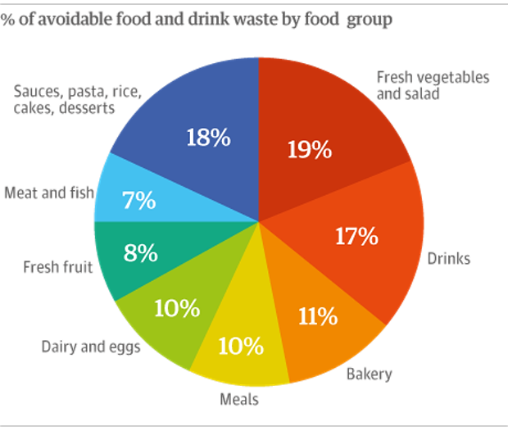
In the UK, who do you think produces more waste?

Some good news…
- From 2010 to 2012, the UK households reduced their waste by 2,2%.
- Between 2007 and 2012 avoidable food waste has reduced by 21%, over 1 million tonnes... ...this amount of food would fill 23 million wheelie bins!
What can I do? R3 or the Waste hierarchy
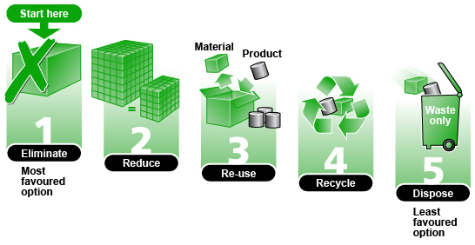
Reduce
Limit the number of purchases that you make in the first place. So, for example, you might limit your household to a single computer.
Re-use
Reuse items as much as possible before replacing them. For example, it generally makes more environmental sense to update your computer rather than get rid of it and buy a new one.
Recycle
Ensure that items or their components are put to some new purpose as much as possible. If your computer is not fit for reuse as is, you can donate it to one of several organizations.

The United Kingdom recycling rate in 2012 was approximately of 43.9%, a rate that increased by 3.6 points compared to 2010.

Plastic
- Recycling just one plastic bottle saves enough energy to power a 60W light bulb for six hours.
- The use of plastic in Western Europe is growing about 4% each year.
- Plastic can take up to 500 years to decompose.

Paper
- Every tonne of paper recycled saves 24 trees.
- Recycled paper produces 73% less air pollution than if it was made from raw materials.

Aluminum
- Just one recycled aluminium can saves enough energy to run a television set for three hours!
- If all cans in the UK were recycled, we would need 14 million fewer dustbins.
- Aluminum cans can be recycled and ready to use in just 6 weeks.

Glass
- The energy saving from recycling one bottle will power a washing machine for 10 minutes.
- Glass is 100% recyclable and can be used again and again.
- Glass that is thrown away and ends up in landfills will never decompose.

Sometimes a fourth R is added to the three basic ones…
Rethink or Recover
Consider our options and think about their impact on the environment. Recover, which is the last R, refers to the practice of putting waste products to use. For example, decomposing garbage produces methane gas (one of the greenhouse gases), which some landfill sites recover and burn for energy rather than letting it dissipate.

Advice for responsible consume:
Ecological farming and gardening
Opt for ecological food. It´s healthier and helps protect the environment.
In ecological farming, the vegetables are grown without pesticides or chemical fertilizers.
In addition, their consumption helps prevent soil and groundwater contamination and encourages a new way of understanding agriculture.
As for ecological farming, its principles are based on free grazing or extensive production, in healthy food for the cattle with ecological or wild products, health care based on therapies and alternative medicines, without the supply of antibiotics, hormones or other substances toxic to the animal or the consumer.
And remember...
- They help maintain the health of farmers and consumers. By respecting the natural rhythms and not using biocides, produced foods are more healthy and balanced.
- With ecological food we get back to the real taste of food, also they preserve better than conventional products.
- The compost, a key ingredient for fertilization in organic farming makes the soil suitable for supporting life and feed the microorganisms that dwell in it, which are the ones who make the substances the plants need available to them. Chemical fertilization, however, mineralizes the soil, reduces microbial life and ultimately impoverishes it.
- Organic farming fertilizes the soil and slows the desertification by improving water retention.
- Organic farming maintains the habitats of wild animals, allowing and encouraging the life of many species thus helping to maintain biodiversity.
- Ecological agriculture and farming reduce energy consumption as they do not abuse the usage of machines.
- It promotes the creation of jobs in the countryside, by requiring, by its very nature, work and presence of farmers.
Look for the seal of ecological farming to ensure that the product you are buying meets the guarantees of the Regulatory Boards.
Ask your regular shop to start offering ecological products (rice, pasta, canned goods...).
Fair trade
A fairer relationship between producers and consumers for the products sold with the fair trade seal:
- The producers are organized into cooperatives and other voluntary organizations that operate democratically.
- The work is done with dignity and with respect for human rights.
- The price paid to the producers allows for decent living conditions.
- The quality of products and their production is assessed taking into account sustainability criteria.
- Buyers often pay in advance to prevent producers from being subject to inadequate financing conditions.
Delicious alternative
Some of the products with fair trade label you can purchase are: sugar and sweets, cocoa and chocolate, coffee, tea and juice.
Find your point of consumption
On this website http://www.fairtrade.net/buying_fairtrade.html you can find a list of stores that offer certified fair trade products in your country.
Look for the Fair trade seal
Fair trade products are identified by the fair trade label or seal, which ensures that the product has been produced and sold according to the international Fair Trade criteria.
Advice for consumption… the shopping cart
If you do not need it... do not buy it
Consumption is becoming a form of entertainment... or even therapy. Every year we buy products that do not need, simply because of their appearance, because they are fashionable... or because we cannot think of anything better to do. Before starting to buy, think about whether you really need the thing you are planning to buy and if you'll actually use it. Make a shopping list before you leave home, it will help you buy things that you really need.
Consume foods from ecological farming
They are healthy and help conserve the environment. They are grown without pesticides or chemical fertilizers. Look for the seal of organic farming to ensure that the product you are buying has the guarantee of the Regulatory Boards.
Buy in-season products
They are much cheaper. But also, by buying in-season products you avoid transport over long distances and conservation and artificial maturation that, besides the energy and chemical costs, reduce quality and even the taste of food.
Best fresh than frozen
If you can choose between the same product fresh, chilled or frozen, choose fresh, unless you are not going to consume it in a short period. If you must choose between refrigerated and frozen products, choose the refrigerated, as the water and energy consumption of refrigerated products and very inferior to their frozen versions (about one third of it).
Buy local products
It contributes to the economy and local culture and avoids transportation costs.
Buy fair trade products
Fair trade networks pay a fair price for the product they sell, and even help farmers in the financing of production and in their training, limiting the intermediaries. Some of the most common fair trade products include coffee, chocolate, tea and clothing.
Carry bag or cart for shopping
Make purchase with your cart, basket or reusable bag (which is washable, spacious and comfortable). Avoid using plastic bags and if you use them, at least reuse them.
Avoid products with excessive packaging
It is preferable to buy products in bulk or packaged in lighter and easily recyclable materials.
Avoid single-use products
Single use products, such as plates, glasses, cutlery or napkins entail an unnecessary waste of such resources as plastic or paper.
Better without foil
The traditional lunchbox and waxed paper are a good alternative to aluminum foil.
Consume tap water
According to some estimates, the consumption of water in plastic bottles supposes 250 times higher CO₂ emissions than those from the consumption of tap water.

