The importance of water for life

Water is fundamental to the development of life and is present in a large proportion in all living beings…
An insect
Seaweed
A medusa
A tree
In human…
Embryo
Children
Adult

In food…
Bread
Almonds
Grape
Cucumber

But water distribution is unequal in the world
With 70% of the planet covered in water, it is hard to imagine that there may be problems with the world's water supply. However, less than 3% of the earth's water is fresh, and most of this is difficult to obtain.
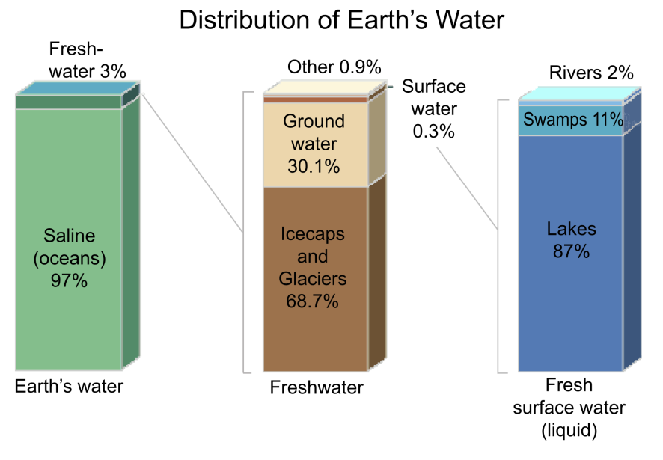
At the same time, water supplies are very unequal on a global scale, depending on the differences in climate, and the balance between the amount of precipitation on the one hand and the loss of moisture from the soil, rocks and plants, known as evapotranspiration, on the other.

One in eight people of the world population do not have access to safe water. Sixty million children are born each year in developing countries who do not have access to safe water.

Did you know…
- That London gets less annual rainfall than either Istanbul or Rome?

- That in UK about one third of our water is lost through leaking pipes before it gets to our home?

Are the countries with the highest supplies of water the main consumers?

Four thousand cubic kilometres of water are used by people each year around the world, for domestic, agricultural and other industrial purposes.
China, India and the United States use the most water. These are also the territories where the most people live. But water use per person is about three times higher in the United States than it is in India and China.
Whilst everybody needs water, people use hugely varying quantities. On average, people living in Central Africa each use only 2% of the water used by each person living in North America.

In the UK, who do you think uses more water?
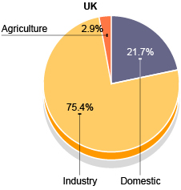
In a direct way, domestic sector represents 21.7 % of the total water consumption in the UK, but…

Is this amount the real one we use? What is the UK water footprint?
The water footprint measures the amount of water used to produce each of the goods and services we use. It can be measured for a single process, such as growing rice, for a product, such as a pair of jeans, for the fuel we put in our car, or for an entire multi-national company. The water footprint can also tell us how much water is being consumed by a particular country –or globally– in a specific river basin or from an aquifer.
The UK has become the sixth largest net importer of water in the world. Only 38% of the UK's total water use comes from its own resources; the rest depends on the water systems of other countries.

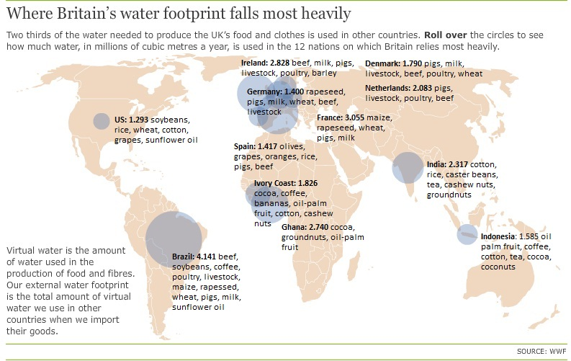

Some data…
- Average household water use for washing and drinking in the UK is about 150 litres a person daily, but we consume about 30 times as much in "virtual water", used in the production of imported food and textiles;
- Taking virtual water into account, each of us soaks up 4.645 litres a day;
- Only Brazil, Mexico, Japan, China and Italy come higher in the league of net importers of virtual agricultural water. People in poorer countries typically subsist on 1.000 litres of virtual water a day;
- Different diets have different water footprints. A meat and dairy-based diet consumes about 5.000 litres of virtual water a day while a vegetarian diet uses about 2.000 litres.
Huge amounts of the food and cotton we consume are grown in drier areas of the world where water resources are either already stressed or very likely to become so in the near future.

Discover… the Water Footprint of Food
PRODUCT |  | LITRES OF WATER NEEDED FOR ITS PRODUCTION
1 KG OF BEEF | 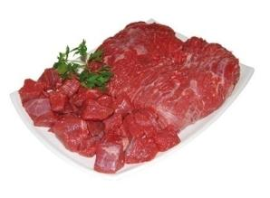 | 16.000 litres
A CUP OF COFFEE | 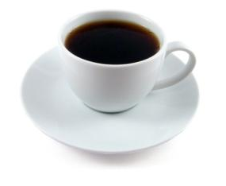 | 140 litres
1 KG OF RICE | 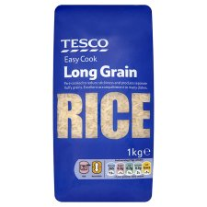 | 3.000 litres
AN EMPTY PLASTIC BOTTLE | 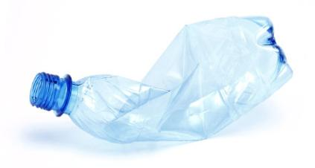 | 7 litres
1 LITRE OF GASOLINE/PETROL | 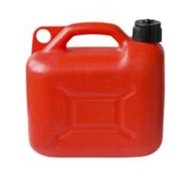 | 10 litres
1 PACK OF SHEETS OF PAPER (80 GR) | 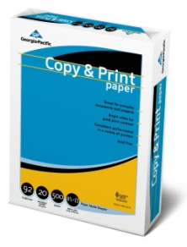 | 1.000 litres

Consumption of water in our daily life

Since we get up… we are using water
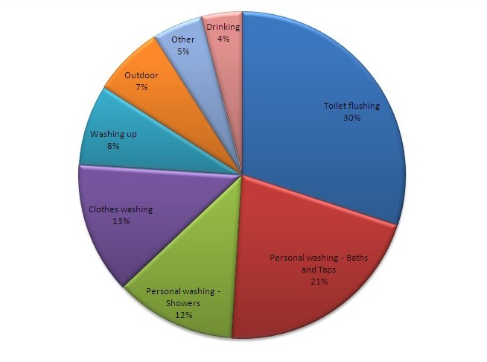

Water is essential for life and for our comfort.

BUT

Is it possible to reduce the consumption of water without reducing our comfort?
Advice for saving water:
General advice
Discover leaks: testing the meter
Record the number the water meter marks before going to bed and read it again the next morning before any use of water is made. If the number on the counter has changed, you may have a leak.
Discover leaks: control the WC cistern
Sometimes water losses in WC are not visible to the eye. If we dye the water in the tank with a harmless dye, we can find out easily if there is a leak.
Close or repair the leaky faucet
The seemingly innocuous dripping tap can mean, ultimately, very significant water losses. A dripping tap loses about 30 litres of water every day.
If you go on a trip, close the stopcock
If you will be away from your home for a few days, it is best to close the stopcock. Thus you can avoid water losses from small leaks or flooding from sudden ruptures.
Advice for saving... in the kitchen
You can save even when washing by hand
The water consumption can be reduced substantially by using a small bowl of water to soap dishes and one for rinsing (or the sink itself closing it with a plug).
If you buy a washing machine, choose a low consumption model
Currently you can find in the market washing machines of a capacity of 7 kg that consume from 42 to 62 litres of water, while for a load capacity 5 kg, the consumption varies between 39 and 52 litres. Considering the efficiency gains, washing machine can be considered low consumption if it uses up to 44 litres per wash (5 kg load capacity) or a maximum of 47 litres if has 7 kilos of load capacity.

If you buy a dishwasher, choose a low consumption model
The water consumption of the models that can accommodate 12 to 13 services ranges from 6.5 to 18 litres per wash. Given the improvements in efficiency, we can consider that a new dishwasher consumes little water if it spends under 10 litres per washing.
Select the most efficient washing programme
Some programmes consume only half the water than others. Read the instructions manual and take a look at the water and energy consumption of each programme. In dishwashers, the programme called "fast" often provide very substantial water savings by eliminating some phases, such as prewash and rinse. Beware of ECO programmes, they are not always those of lower water consumption.
Detergents: better non-phosphate ones
Detergents containing phosphates contribute to the proliferation of algae in rivers and reservoirs, depriving rest of the aquatic fauna from oxygen. There are phosphate-free laundry detergents and dish soaps in the market. Choose them.
Do not throw used oil down the sink.
Save it in a small container. When it is full, you can use it to make soap or take it to the recycling centre.
If you like your water cold, put it in the fridge
To obtain chilly water, do not let the tap run. Instead put a water bottle in the fridge.
Place an efficient aerator also on the sink tap
Advice for saving... in the bathroom
Choose the shower instead over a bath
A shower consumes, on average, a quarter of the water required for the bath: it takes around 200 litres of water to fill the tub, while a five-minute shower consumes around 50 litres.
Install a low-flow shower head
Efficient shower consumes about 6-7 litres of water per minute, compared to 12-15 litres of traditional shower head. Its installation is very simple: just unscrew the old shower head and screw the new one on the hose.
Control your shower time
It is easy to lose track of time in the shower. There are simple and inexpensive devices such as hourglasses, which let you know when you 4 or 5 minutes have passed by.
Open the tap only when you need the water
You can close the tap while you are soaping. Do the same while you brush your teeth or shave.
Use the toilet flush correctly
If your tank has a dual switch, use the reduced discharge when you need little water. You will use only half of the water from the tank and you will achieve the same result. If you don’t have a dual switch, you can introduce a bottle to reduce the capacity of the tank.
If the hot water takes time to arrive...
You can use a bucket or bowl to collect the water from the shower until the water is hot. With this water you can water the plants, wash floors, etc.
Place a paper bin in the bathroom
It will be easier to prevent the WC from being used as a garbage bin. You will save water and avoid contamination.
Place an aerator on the sink tap
If your tap is not efficient, you can install an aerator. You will save between 40 and 60% of the water while maintaining a similar sensation of wetness. There are very cheap (about £2) and are installed simply by screwing them on the conventional taps.
Advice for saving... in the garden
Take advantage of rainwater to water the garden
Rainwater that falls on rooftops and courtyards can be used for watering the garden. Once collected by the gutters or drainage the water can be collected in a small reservoir where it is stored and then used for irrigation.
A small and half-buried container is ideal for storing rainwater, but we can also use other improvised containers, ranging from a barrel to an old bathtub. The container should be placed in a highest area of the garden, to use gravity for irrigation.
Water during the coolest hours of the day
Avoid evaporation losses and damage to plants.

Save water is also save money…
Did you know that…
…nearly a quarter of your energy bills come from heating water – that’s an average of £228 per year for a typical family?

